**Django-ERP User Manual**

**Workflow Management**

## A term introduction

* **Operational terms**

Submit: Start the process approval or submit the current business document to the next node for approval. This operation has a follow-up operation, namely Confirm Submission.

[Agree]: After entering the approval process, the approver can select one of the three operations to indicate that he agrees with the content of this business document. After selecting this operation, the next stage of approval will be entered;

[Reject]: After entering the approval process, the approver can select one of the three actions to indicate that he/she disagrees with the content of this business document. After selecting this action, the current process ends.

[Terminate]: After entering the approval process, the approver can select one of the three operations, indicating that the approver wants to cancel the business document, reject in principle, terminate the approval, and end the process;

[Confirm submission]: Confirmation operation after submission. The submitter can choose the next node processor;

[Restart]: The submitter can restart the process after rejection;

* **Definition of terms**

【Workflow Model】: An information-based expression of the actual business process, consisting of a group of interrelated nodes with a sequence of nodes; each workflow model must be associated with a business model and marked as an approval model for a specific business model.

[Workflow Node]: Nodes that make up the workflow model, used to define the processor, next node, execution action, etc.

[Workflow Instance]: When a business model document starts a process approval, a workflow instance is generated, which records the initiator, current processing node and other information to carry the workflow approval information of the business document;

[To-do tasks]: tasks generated by workflow push that need to be processed by the currently logged-in user;

[Approval Record]: the approval records of business documents, including approval time, approver, and approval opinion information;

## 2. Workflow Definition

### 2.1 Workflow Model Definition

Click [Workflow] - [Workflow Model] to enter the workflow model list page, as shown below

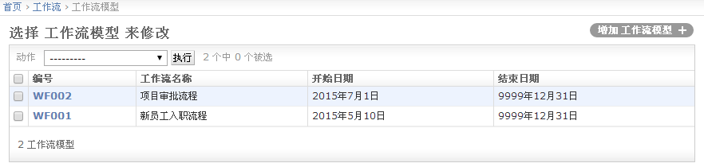

Click the [Add Workflow Model] button to open the new form page:

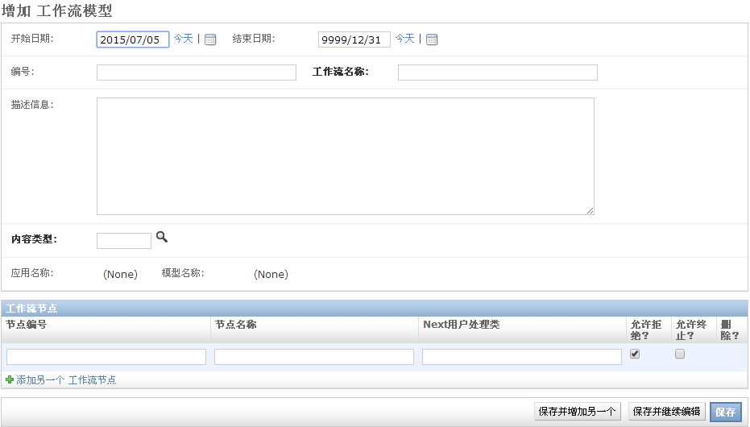

The meaning of each interface element is explained as follows

[Start Date]: The start date of the model, used to define the effective start date of the model;

[End Date]: The end date of the model, used to define the effective end date of the model;

[ Number ]: Automatically generated serial number, used for retrieval;

[Workflow Name]: The name of the workflow, such as [Employee Onboarding Approval]

【Description information】: detailed description information;

[Content Type]: The business model of the business document corresponding to this process;

[Application Name]: automatically generated, which is the module name of [Content Type];

[Model Name]: automatically generated, which is the model name of [Content Type];

[Workflow Node] - [Node Number]: Automatically generated, by default, numbered in order;

[Workflow Node]-[Node Name]: Approval node name, such as [Supervisor Review];

[Workflow Node]-[next user processing class]: a custom user processing class, which is empty by default;

[Workflow Node] - [Allow Rejection?]: Whether to allow the current node to reject the approval;

[Workflow Node] - [Allow Termination?]: Whether to allow the current node to terminate the approval;

### 2.2 Workflow Node Definition

When defining a workflow model, the node name information of the model is simply defined, and detailed information such as the node's processor, next node, and execution action are not fully defined. The detailed information can be improved in the [Workflow Node].

Click [Workflow] - [Workflow Node] to enter the workflow node list page, as shown below:

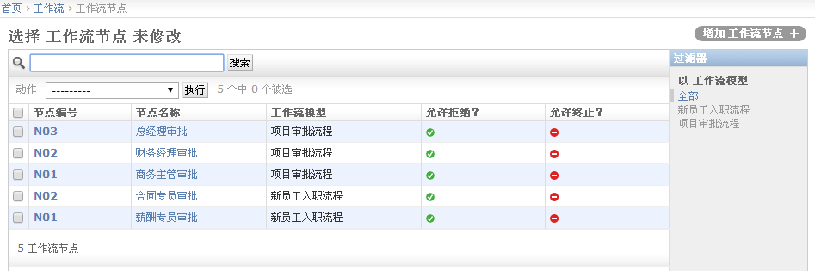

The list above shows all workflow nodes. You can filter by clicking the corresponding workflow model on the right to display only the nodes of a specific model, as shown below

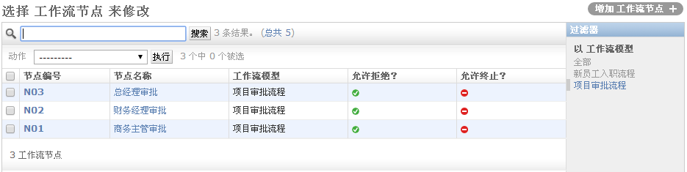

Click the link corresponding to the [Node Number] or [Node Name] column to enter the detailed information page, as shown below

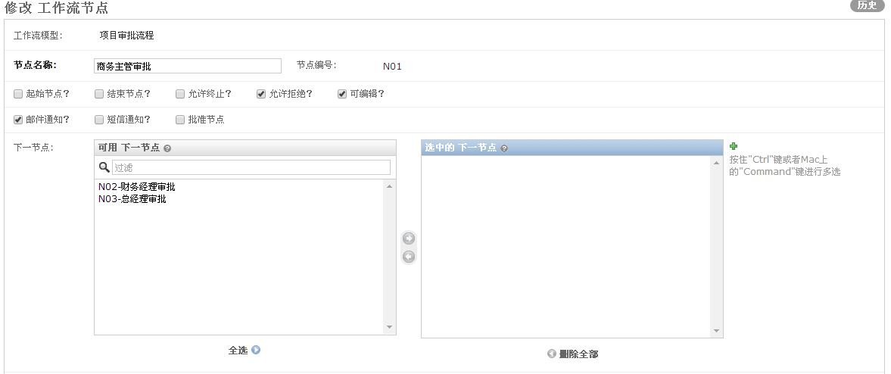

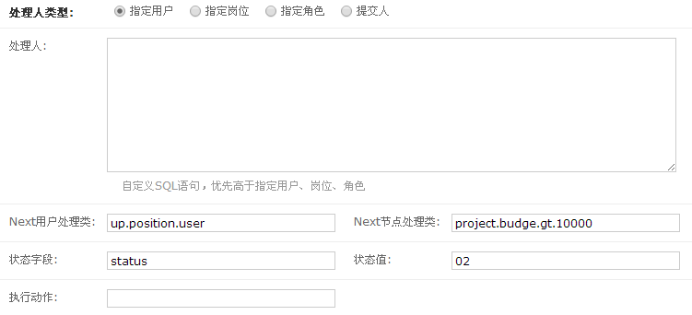

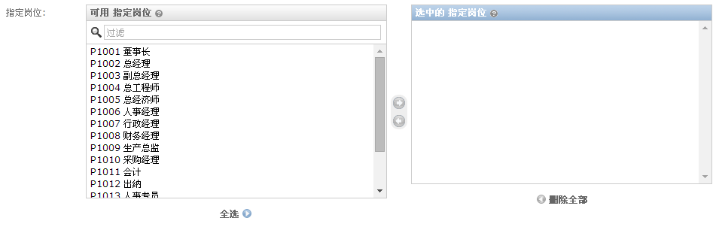

The meaning of each field on the page is explained as follows:

[Workflow Model]: cannot be edited, indicates the name of the model to which this node belongs

[Node Name]: The name of this node, which is brought from the workflow model definition page and can be modified here;

[Node Number]: Automatically generated and cannot be modified on this page;

[Starting Node?]: Indicates whether this node is the starting node. By default, the system executes in the order in which the nodes are created;

[End Node?]: Indicates whether this node is a termination node. The system executes in the order in which the nodes are created by default.

[Allow termination?]: Indicates whether this node allows the approval to be terminated directly and the process to be invalidated;

[Allow rejection?]: Indicates whether this node allows rejection of approval and ends the process;

[ Editable? ]: Important. By default, once the document data enters the process approval, it cannot be changed. In special cases, the approver of the current node needs to be able to edit it. If editing is required, just select this checkbox.

[Email Notification?]: Notify the approver via email. This function is a planned function and is not implemented in this version.

【SMS Notification?】: Notify the approver via email. This function is a planned function and is not implemented in this version.

[Approval Node?]: Is it an approval node? If it is an approval node, try to update the value of the status field to the specified value;

[Next Node]: Select the next node of this node. If it is empty, it will be executed in the order of node creation and the process will end automatically at the last node.

[Processor Type]: Define the processor type for this node. Specify the user, position, or role. After selecting the type, select the specific user, position, or role below.

[Processor]: For more complex dynamic processors that cannot be processed by specifying users, positions or roles, you can enter SQL statements here. The template language {{expression}} is supported to obtain the value of the business object field;

[next user processing class]: For more complex dynamic processing, it is impossible to process through SQL statements. You can write a class to process it. The system supports processing through plug-in classes. The up.position.user plug-in is provided by default to return the parent position user of the current user. You can view examples in plugin.wfusers .

[next node processing class]: For conditional node jumps, the system supports jumps through plug-ins. You can view examples in plugin.wfnodes .

[Status Field]: If you need to update the status of the business document, you need to enter the field name here;

[Status Value]: After the user clicks [Agree], the value of the [Status Field] will be updated to the currently specified value;

[Execute Action]: If you have special business needs, you can register an execution action here, such as sending a message, creating a specific business document, etc. The system supports extension through plug-in classes. You can view examples in plugin.wfactions ;

[Specify User|Position|Role]: Select a specified user, position or role;

## Three workflow operations

### 3.1 Submission

If the current business document is configured with a workflow model, after saving the document, the user can select Submit to enter the process approval; as shown below:



After clicking the [Submit] button, enter the [Confirm Submission] page;

### 3.2 Confirm submission

Confirm submission is used to reconfirm whether to submit to prevent misoperation

In the startup process, when the user clicks the [Submit] button, the following page appears

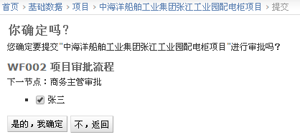

After clicking [Yes, I am sure], the page will jump. If the startup is successful, the following message will be displayed

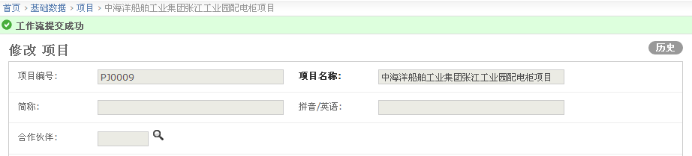

At the same time, the page content cannot be edited;

Users can click the [History] button to view the approval history, as shown below:

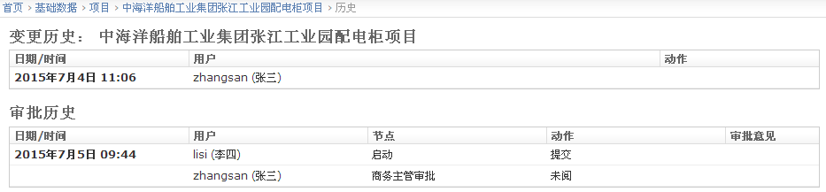

After submission, user [Zhang San] can see the following information in the To-Do Tasks column:

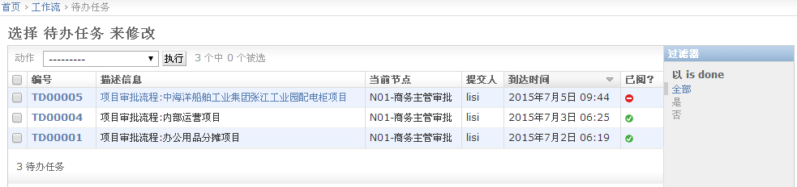

### 3.3 Consent

The user enters the details page through the to-do task bar. There are 3 optional approval operations at the top of the page.

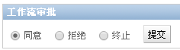

[Agree] means agreeing to the contents of this document and proceeding to the next step. Click [Submit] to display the following page:



### 3.4 Rejection

The user enters the details page through the to-do task bar. There are 3 optional approval operations at the top of the page.



[Reject] means that you do not agree with the content of this document, but allow the submitter to modify and resubmit. After clicking [Submit], the following page will be displayed:

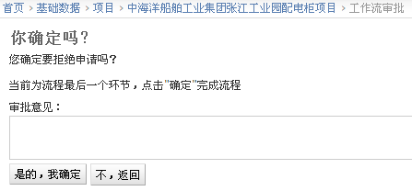

Click [Yes, I am sure] to complete the approval. The submitter can see the following interface



### 3.5 Termination

Users enter the details page through the To-Do Task Bar. There are three optional approval actions at the top of the page.

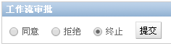

[Terminate] means to cancel this process and not allow users to resubmit. After clicking the [Submit] button, the following page will appear:

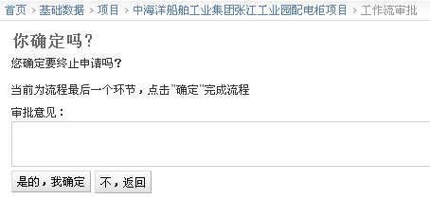

### 3.6 Resubmission

When [Resubmit] is clicked, all approval information of this process will be cleared, and the user can click the [Submit] button again below for approval;

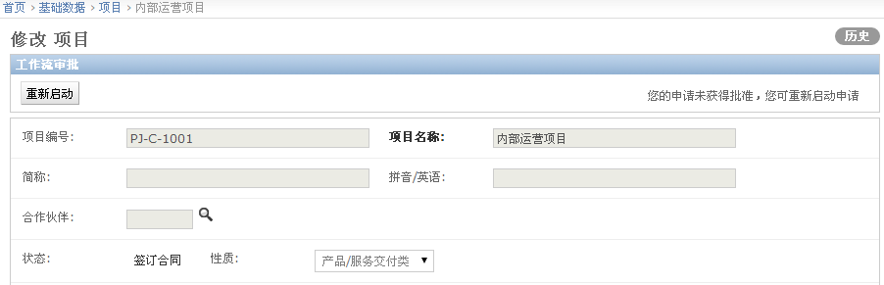

## 4. View workflow approval history

Users can click the [History] button in the upper right corner of the form to view the workflow approval history, as shown below:

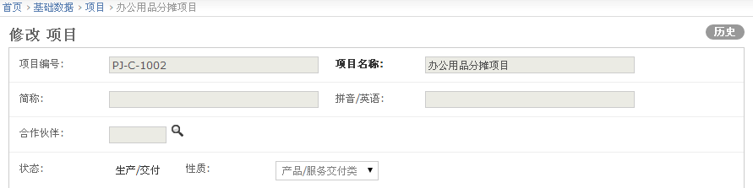

After clicking, you can see the following approval history page

